 |  | 
MANSOURA UNIVERSITY
FACULTY OF ENGINEERING
ARTIFICIAL INTELLIGENCE ENGINEERING Program

PROJECT TITLE
Project members | ID number

Supervisor
Supervisor Name

Academic Year: 2022 – 2023
July 2023

ABSTRACT
Write your Abstract here.

ACKNOWLEDGEMENTS
Write your ACKNOWLEDGEMENT here.

TABLE OF CONTENTS (after updating the Table of contents, Apply TOC1 Style to it)
ABSTRACT ii
ACKNOWLEDGEMENTS iii
LIST OF ABBREVIATIONS vi
Nomenclatures vi
1 Chapter (1) Title (Heading 1 Style) 2
1.1 Heading 2 Style (How to Insert Figures) 2
1.1.1 Heading 3 Style (How to Insert Tables) 2
2 Chapter (2) Title (Heading 1) 6
3 Chapter (3) Title (Heading 1) 8
4 Chapter (4) Title (Heading 1) 10
5 Chapter (5) Title (Heading 1) 12
6 Chapter (6) Title (Heading 1) 14
References 16
APPENDICES 18
Appendix A. 18
Appendix B. 19

LIST OF FIGURES
Figure ‎1-1 Power station. 2

LIST OF ABBREVIATIONS
CFD | Computational Fluid Dynamics

Nomenclatures
T | Temperature (K)

CHAPTER 1
Chapter Title

Chapter (1) Title (Heading 1 Style)

Heading 2 Style (How to Insert Figures)
Text (Normal Style)
As shown in Figure ‎1-1, shows …. To add a new Figure, copy the following Figure with its caption and paste it wherever you want. Then, change the photo by clicking on the photo with a (Right Click u Select: Change Picture ()u Select either From a File… or Clipboard or whatever you like). After this, select the caption and Update the field either by pressing the F9 button or Right Click u Select: Update Field (). Finally, to mention the Figure in the text (should be in the nearest paragraph directly before the Figure), go to the Insert Ribbon () u Select: Cross-reference (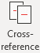) u Under the Reference Type: Select: Figure, while under the Insert reference to: Select the 2nd choice, Only label and number as follows 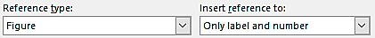.
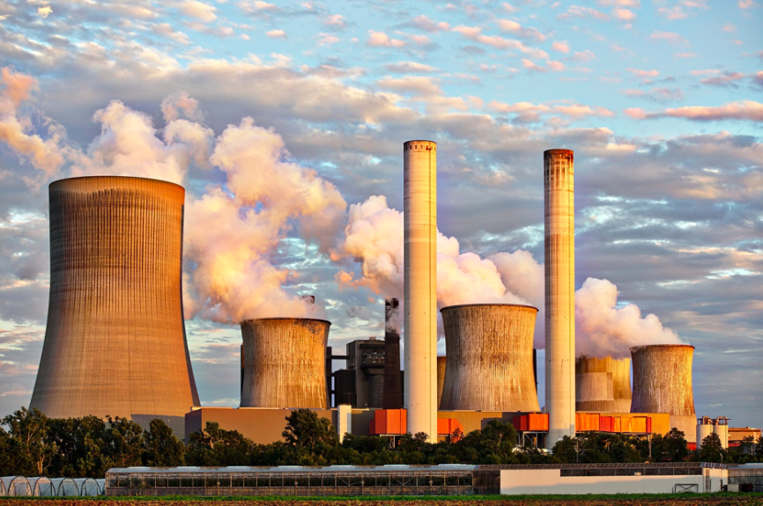
Figure ‎1-1 Power station.

Heading 3 Style (How to Insert Tables)
Text (Normal Style).
As shown in Table ‎1-1 shows …. To add a new Table, copy the following Table with its caption and paste it wherever you want. After this, select the caption and Update the field either by pressing the F9 button or Right Click u Select: Update Field. Finally, to mention the Table in the text (should be in the nearest paragraph directly before the Table), go to the Insert Ribbon u Select: Cross-reference u Under the Reference Type: Select: Table, while under the Insert reference to: Select the 2nd choice, Only label and number as follows:
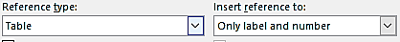
Table ‎1-1 Table caption.

Heading 4 Style (How to Insert Equations)
Text (Normal Style).
Equations are written in borderless tables as follows:
$$Write your equation here…$$ | (‎1-1)
To add any new equation, just copy the previous Equation Table and paste it wherever you want. After this, select the Equation Number and Update the field either by pressing the F9 button or Right Click u Select: Update Field.

CHAPTER 2
Chapter Title

Chapter (2) Title (Heading 1)

CHAPTER 3
Chapter Title

Chapter (3) Title (Heading 1)

CHAPTER 4
Chapter Title

Chapter (4) Title (Heading 1)

CHAPTER 5
Chapter Title

Chapter (5) Title (Heading 1)

CHAPTER 6
Chapter Title

Chapter (6) Title (Heading 1)

REFERENCES

References

Appendices

APPENDICES

Normal text style.

Normal text style.

